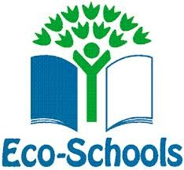
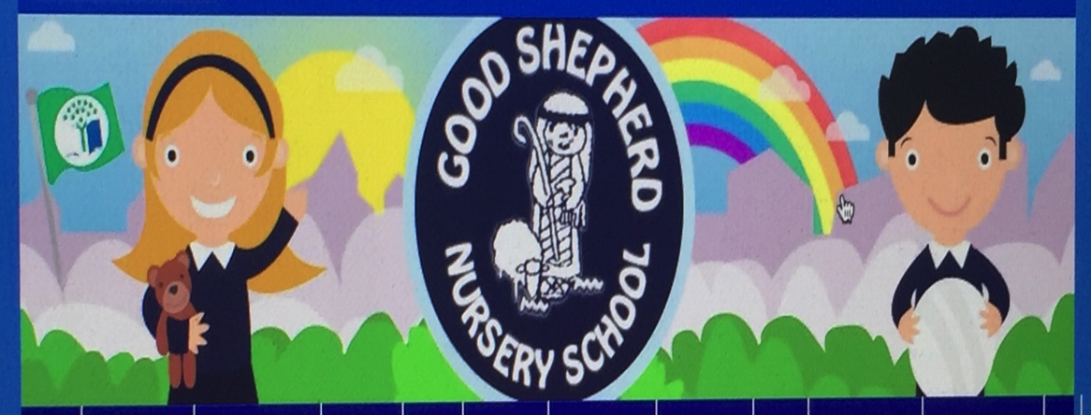
March News

- Children will continue to investigate our garden area , looking at the growth of seeds/bulbs we planted during 1st term

- Regularly weeding large planters ,noticing the difference in weeds from plants or flowers.

- Talking about how to look after vegetables, tomatoes, radishes, cress and spring onions and what is needed.

- Planting Sunflower seeds in recycling pots, learning how to make them using old newspaper. (Daily Home challenge)

- Children will continue to ensure bug hotel is well stocked with leaves, hedging and greenery. (make a bug hotel at home)

- Planting summer bedding plants in hanging baskets/pots.

- Eco display boards kept up to date

- Continuing to offer a wide range of fact/fiction books and learning experiences connected to Eco these of healthy living, outdoor learning and biodiversity.

- Children will be involved in a waste audit -getting ready for our Big Wheelie Bin Challenge

- Children will create displays about “The rubbish monster”

- Children will take part in our regular Jump, Jiggle & Jive /Sonal Sports sessions that promote healthy living,

- Weekly themes are linked to our Eco topics.

