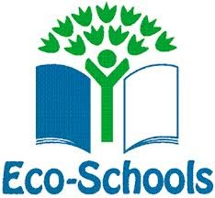
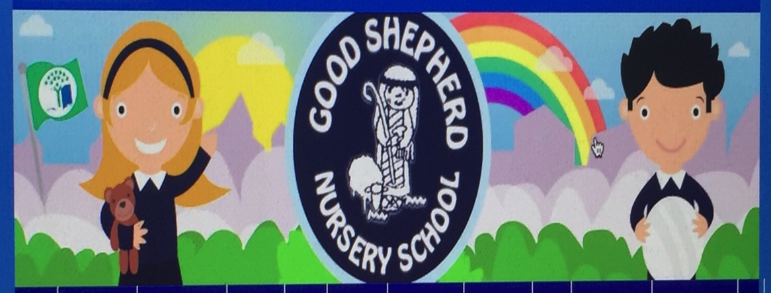

APRIL

- Children will learn the life cycles of caterpillars,and watch the changes in real life.

- Cash for clobber programme recycling old clothes and junk (guidance permitting )

- Children will take part in the Big spring clean up Programme (virtually) - “cleaning up “within local environment.

- We will be treated to a virtual visit from Mambo and Jazz The health Action Puppets talking about 4 Golden Rules

- Children will use our water butt to water plants and be aware of the need to water plants/flowers

- A farm Roadshow visit to the school (Covid regulations permitting)

- Eco display boards and seesaw Eco messages will be regularly shared

- Continue with all Eco themes and messages.

- Children will take part in regular Jump, Jiggle & Jive / Sonal Sports sessions, promoting healthy living.

- Continuation of forest school themes.

- Continuing to offer a wide range of fact/fiction books to support learning experiences connected to wider ECO themes, Healthy living, saving energy, outdoor learning and biodiversity.

