**Baking**

These [**Chocolate Nests**](https://www.mykidstime.com/food-and-recipes/these-chocolate-nests-are-simple-to-make-and-yummy/) are really simple to make. Kids love decorating their nests with the eggs, and even though they are a treat, they do have some extra fibre in them!

www.allrecipes.com

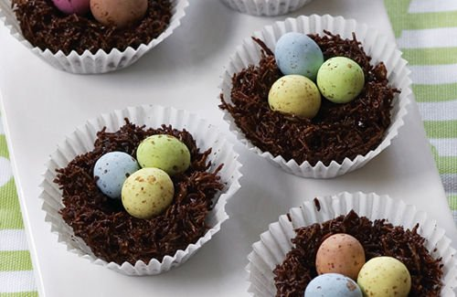

Circle Time

Circle Time is such a great time for children to learn the social skills of being together as a large group AND to learn more about your Spring Theme!

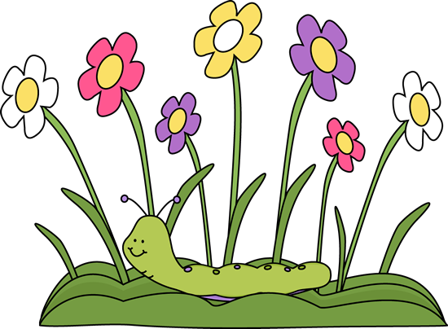

Head to a nearby park or forest and go on a daffodil or bluebell hunt. It’s nice to leave the flowers growing for next year but have some fun seeing who can spot the first daffodil or bluebell, and who can count to 100 flowers!



**Dance Routine**

**Create and learn a dance routine or favorite song, show your whole family, whu not dress up and really perform. Watch the Greatest Showman.**

**A game for the whole family, let your child be simon and cvall out the different instructions Simon Says “touch your nose etc……**

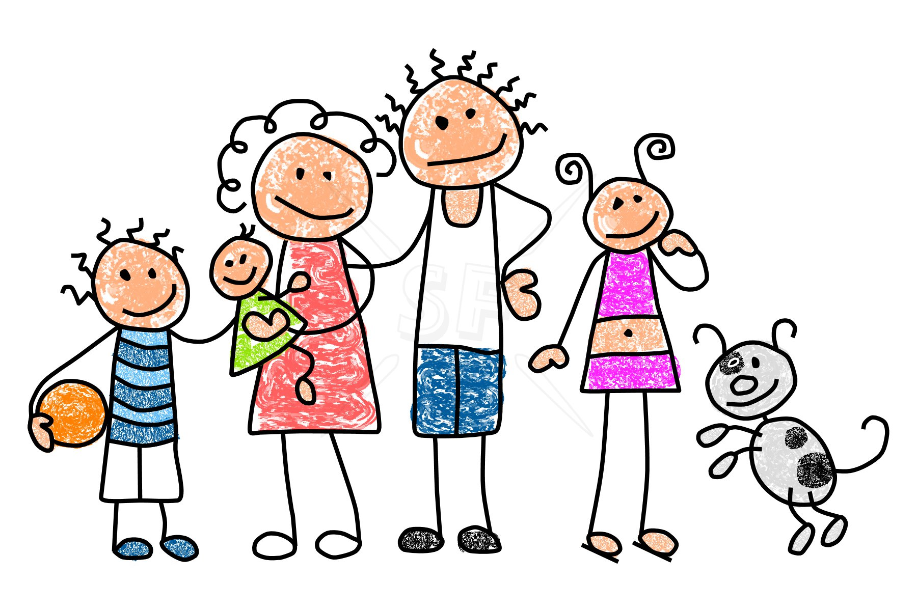

**Physical Activity**

**Jo Wicks. https://youtu.be/SbFqQarDM50**

**Get everyone in family to join in with something high energy**

**“Sticky Kids “**

https://youtu.be/SG_2_e8QCO8

**Teddy Bear Picnic**

Set up all your teddies or dolls at teatime for a special tea ! enjoy the fun.

Song : If you go down to the woods today.

https://youtube/djI4cRR-5es

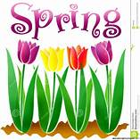

Spring

**Show and Tell** 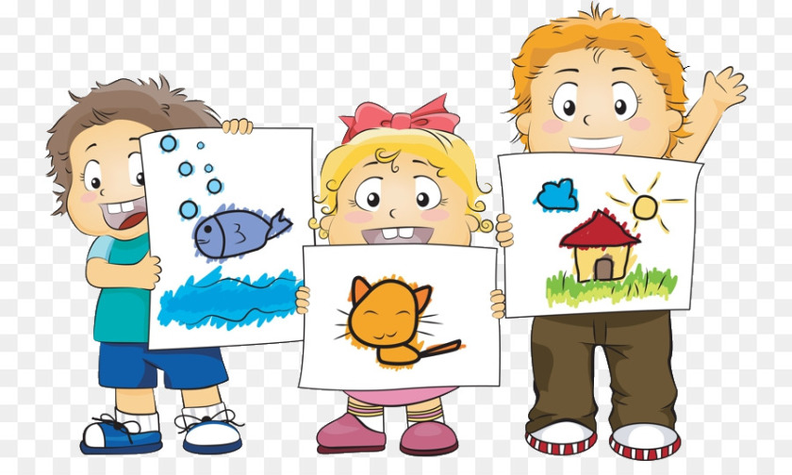

Everyone has to find one thing in their house/classroom , show it to their family/class and talk about it or sing or song

Everyone has to sit back and listen.