Language Development

The Very Hungry Caterpillar

* Pencil control
* Mark making
* Reading
* Sharing stories
* Listening and attention
* Games
* Following instructions
* Repetitive & Rhyme in story

The World Around Us

* Growth 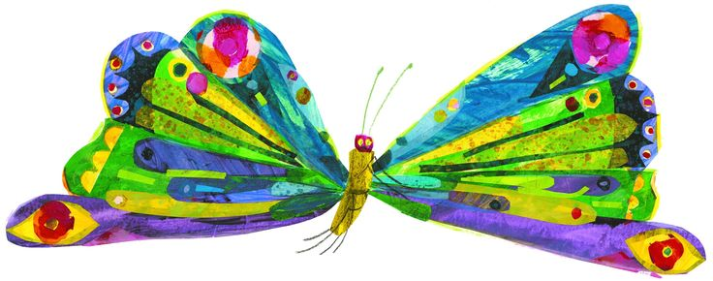
* Different types of plants
* Habitats and where insects /animals life
* Lifecycles
* Healthy Eating
* minibeasts

The Arts

* Singing
* Action rhymes
* Using a range of instruments
* Learning rhythms to music

Personal, Social & Emotional

* Being healthy
* Sharing skills
* Being a kind friend.

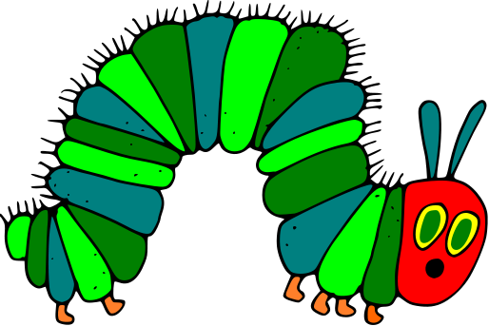

Physical development

* Jumping
* Throwing
* Ball skills
* Trim trail

Early Maths

* Experiences in numbers to 10
* Counting to 10
* Correspondence 1-1
* matching quantities
* same and different concept
* number formation if ready
* patterns
* 2D shapes
* 3D Shapes

