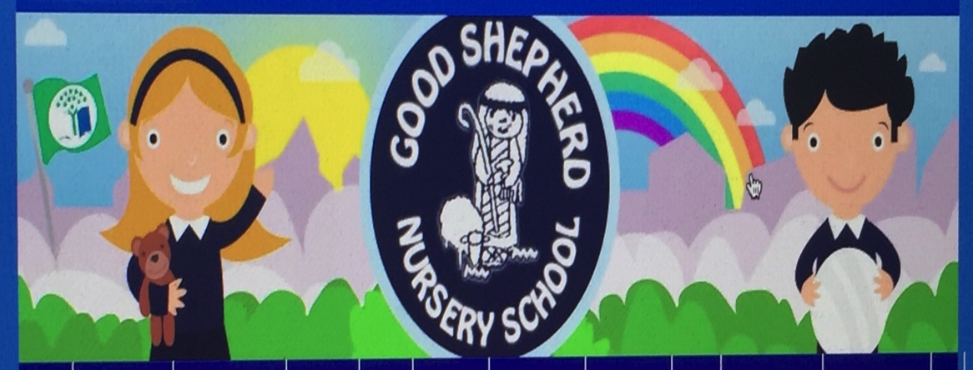
Good Shepherd Nursery School DECEMBER : Outdoor Planner

AREA | TEACHING AND LEARNING POTENTIAL (SKILLS) | RESOURCES | PROGRESSION
SAND HOUSE  NOT IN USE IN DECEMBER  Focus on Small Play houses instead | The children will:  - Enjoy imaginative play in the small plastic houses..  - Ensure door only opens outwards  Numeracy:  Count out chairs needed for number of children playing.  Rule  No hands into mouth after playing with sand.  No throwing sand out of pit through planks. | Four Play Houses, prams, buggies, trolley  Small chairs. | Development of friendships across the two classes.
SMALL EQUIPMENT | The children will:  - Develop throwing/catching skills  - Develop balance  - Gather up leaves on patio and garden area and use wheelbarrow to transport  Golden Rule  No digging up flowerbeds or no hands into soil.  No lifting up branches for inappropriate dangerous play. | Bean bags  Hula Hoops  Rakes and Spades  Stepping Stones  Balancing Beams | Begin noticing bulbs shooting up! Who remembers what we planted?
LARGE MOVEMENT  (balance, spatial awareness) | The children will:  - Develop pedalling skills  - Gain confidence on larger taxis and tractors. | All vehicles. Bicycles  Cars (cosy)  Scooters.  Wooden play trail | Encourage quieter children to try scooters – 2 wheeled.
CREATIVE | The children will:  Discuss where to put range of food for birds in colder weather.  Involved in creative role play  Use small furniture in sheltered area.  Access writing areas | Hanging up of bird seed, fat and nuts.  Willow Dome – campfire role play  4 toadstool seats, 1 table.  Moving plastic  Seetee into this area

AREA | TEACHING AND LEARNING POTENTIAL (SKILLS) |  | RESOURCES |  | PROGRESSION
LARGE SCALE CONSTRUCTION | The children will: take turns, share, use imagination  Numeracy:  Counting up to five  Sort for colour  Sort for size |  | Lego Blocks  Community Blocks-Large + small with photo of children on blocks  Plastic shaped blocks |  | N.B Hall Play Used inside as weather too cold for this activity  Incorporate porch area for children to play of outside too cold
The Growing/Biodiversity Eco Theme | Children will have a greater awareness of growing areas within nursery |  | Raised beds  Gardening tools + equipment watering can and but
ALUATION |  | ACTION FOR SPECIFIC CHILDREN  Staff will organise the outdoor sessions to make best use of weather conditions.  Activities chosen will be those most suited to keeping the children moving and warm.  Ensure when its icy/slippy – children do not run.  Specific children may need to follow visual cues for outdoor play. |  | CHILDREN’S RESPONSE TO PLANNED ACTIVITIES.

