Early mathematical Experiences

Understand one-to-one relationships, e.g., one toothbrush to one person, one appointment card to one person, etc. Learn set times, e.g., snack times, meal times, time to brush teeth. Discuss dental visits- at least once a year. Discuss healthy eating message five pieces of fruit or vegetables each day. Sort, match and count different type/colours of fruit, vegetables, toothbrushes, etc.

Creating opportunities for 1-1 correspondence, patterns, sequencing, shape,

space and relationships.

The Arts

Talk about the colour and shape of different fruit and vegetables Prepare snacks and drinks that are safe for teeth

Complete challenges linked to dental health

Colour/paint activity sheets on – visiting the dentist, healthy eating, tooth brushing, etc. Dental health issues can be explored through the use of music and or drama and visit from dental hygienist.

Printing and experimenting with toothbrushes in their art experiences

Display on Healthy living -connected to major ECO Topic.

The World Around Us

Develop awareness of space, e.g., layout of dental surgery, waiting room, etc. Recognise and use dentists / nurse uniforms in role-play. Know and use positional and directional words, etc., up, down, backwards, and forwards. Setting up roleplay dental area at home with family.

Discuss what makes teeth rot/decay. Discuss healthy eating, eg., foods and drinks which are safe for teeth. Discuss the importance of brushing at least twice a day with fluoride toothpaste. Discussion good and bad food -supported by stories and songs.

Use of interactive whiteboard

Physical Development

Develop manual dexterity and hand/eye co-ordination through activities on large plastic teeth or specific activities set up with toothbrushes in sand and water areas.

Fine motor skills can be developed by completing jigsaw puzzles and other resources on a dental/ nutrition theme

Children can practise skills using large teeth models and their own teeth brushing times

Personal, social and emotional development

Take part in group play, taking turns at being dentist, dental nurse, patient, etc. Becoming familiar with dental instruments, equipment, associated sounds and smells, etc. Develop and express feelings, emotions through stories, rhymes, music and drama. Take part in tooth brushing activities. Choose and discuss snacks and drinks that are safe for teeth. Linking this to our Eco theme of Healthy Living.

Language Development

Become familiar with names of staff, e.g., dentist, dental nurse, receptionist, hygienist, etc. Learn names of furniture and instruments, e.g., dental chair, light, drill, mirror, etc. Learn names of different teeth, eg., molars, canines, incisors. Identify main parts of the month, e.g., lips, tongue, cheeks, teeth. Discuss functions of teeth, e.g., smiling, talking, singing, eating, etc. Give advice about dental care. Listen to others. Take part in role-play, e.g. Dentist dental nurse, patient. Explore dental health issues through the use of stories, rhymes, music and drama. Using resources, books, posters, stickers to reinforce our healthy eating and 1 2 3 Health Scheme.

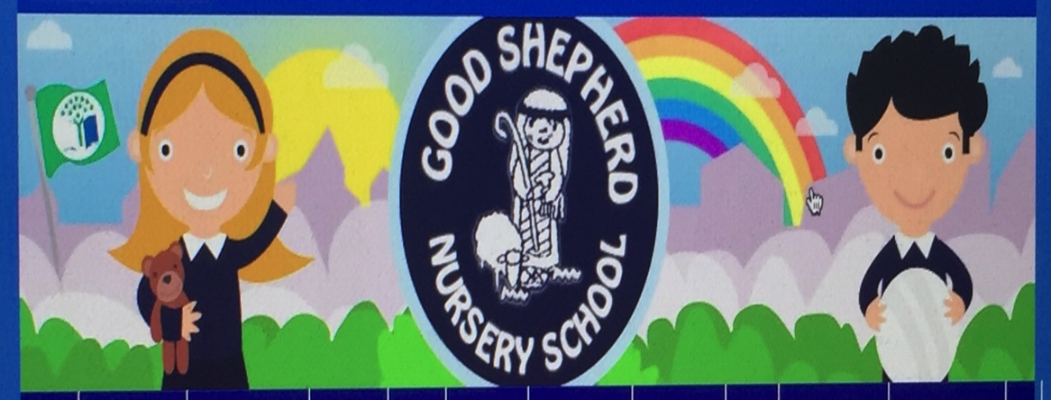Dental Health

Healthy eating,

Tooth brushing,

Visiting the dentist