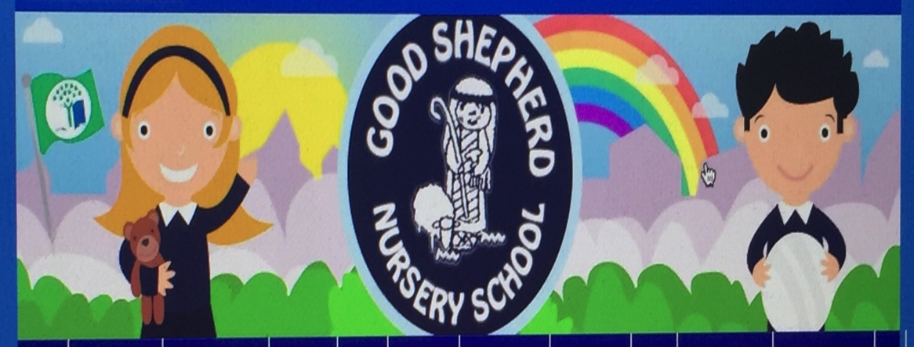

February News
- Children will investigate and become involved in a variety of seed planting learning experiences, either indoors or outdoors, both individually or in group activities. Children will be introduced to cress, herbs, marigolds, peppers, parsnips and radishes. Staff will share planting activities
- Children will investigate and notice how seeds and bulbs grow-using stories and youtube videos
- Encourage parents to allow opportunities for their children to cut a variety of fruit and vegetables at home having time to explore and experiment and discuss, colour, size, shape, taste and texture.
- Offer parents challenges and activities that allow children to explore and investigate all types of living/non living things in any outdoor areas.
- Children will have time to explore our minibeast /wildlife house, having access to a wide variety of Eco fact/fiction books, gardening and wildlife magazines that teach about the world around them, living things and nature.
- Children are encouraged to look, observe, investigate and explore minibeasts that are found outside. Finding them in our bug hotels and under tree stumps.
- Children will learn about the importance of minibeasts in their world-biodiversity theme.
- Continuing to develop our theme of healthy living by reading fact/fiction books connected to this theme and taking part in activities that promote and enhance this.
- Children will take part in our Jump,Jiggle and Jive classes,live sessions and Sonal sportz.

