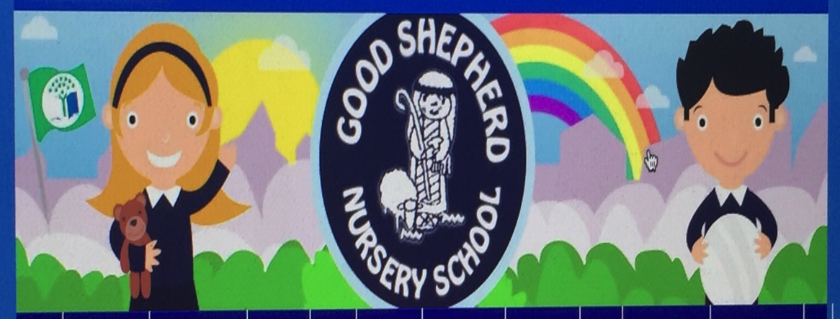
Good Shepherd Nursery School

Parental Agreement during the Covid-19 Pandemic.

This agreement has been drawn up with the endorsement of the Board Of Governors as part of our new way of working policy linked with the Covid 19 situation. It is has been created in response to support our nursery community to return in the safest way possible following Government Guidelines.

This agreement is in place to ensure we have a clear understanding of the expectations for parents, children and the nursery staff as we re-open during this pandemic.

We follow a very child centred ethos with in our nursery and will, through a nurturing approach help our children to follow new procedures around hand washing, coughing and sneezing, personal space, bubbles as well as learning to move safely around the nursery school. Staff will teach these reminders regularly to ensure our children know the expectations and are clear and sure how to keep themselves and their friends safe at nursery.

Please try and encourage your child to:

- Wash their hands carefully before leaving the house to come to nursery
- Stay in their special bubble of friends when at nursery school
- listen to their staff in school and follow instructions that keep them and everyone safe.
- Use tissues and promote the “catch it, bin it, kill it” message
- Think about the personal space of others
- Talk about their feelings in relation starting nursery school.

parents

I agree:

- to have my child’s temperature checked on arrival if required and answer Covid related questions daily on arrival each morning
- to use hand sanitizer each morning on arrival into nursery school
- to drop and pick up my child at the allocated time.
- that there will only be 1 parent present during drop off/collection time
- only parents who are symptomatic free or completed isolation will be permitted to drop off and collect child
- to be considerate and follow social distancing when outside nursery
- not to congregate with others after dropping off or collecting my child
- to adhere to the one way system in place at all times
- I agree to allow my child to be handed over to a member of staff in the morning unless distressed
- to give any message to the teacher via the seesaw app rather than speaking at the classroom door, understanding that face to face meetings may be unavailable.
- that I will not allow my child to bring in any toys/soft comfort toys from home unless prior agreement from staff
- only to come into the nursery building if I have an arranged appointment with my child’s teacher
- to keep my child at home if they are unwell, if they have been in contact with someone who has tested positive. In this case I will inform the nursery and self-isolate my child for 14 days.
- to have my child tested if they are displaying any symptoms of Covid 19,ie,new continuous cough, high temperature of above 37.5,loss of taste or smell
- to keep my child at home if someone in the house has tested positive or suspects they may have Covid-19 and will self isolate for 14 days.
- to collect my child straight away when contacted if my child becomes unwell whilst at nursery (The nursery’s decision will be final)-following procedures within the isolation policy
- to read and agree to the nursery’s isolation policy if my child displays symptoms in the nursery (policy attached)
- that my child may not attend on a full time basis
- to participate in any home schooling that will be offered.
- and understand that staff will not routinely offer intimate care (changing due to a toileting accident)
- that if my child is not toilet trained they may have their date delayed or have a reduced day.
- to not park/drive into the school grounds, even if the gates are open.
- If someone other than a parent is dropping off my child that person will not be permitted into the nursery. The child will be collected from the door and taken into the classroom by a member of staff.
- if anyone other than a parent is collecting or dropping off I will inform them of all the nursery procedures
- If I have any concerns, I will raise these immediately with staff or principal
- I will ensure my contact details and information are kept up to date
- that siblings will not be permitted into the nursery school at drop off and collection times.

Child’s name:----------------------------------

Parent’s name:-----------------------------------

Date: ------------------------------

