April’s Newsletter 2022

April

Our virtual Annual Easter Bonnet was a great success thank you for all the lovely creations that were made at home.. The children were very excited to take part.

Its hard to believe that we are nearing the 2nd nursery term. Take time to congratulate yourself on how well you have supported your children through all home/school learning activities. We are very much looking forward to a ”brighter” 3rd term

**www.goodshepherdnurseryschool.com**

**Farm visit**

The farm will bring their roadshow tour to the nursery . Date to be confirmed

This month the children are learning about the Farm, growing and lifecycles

Our colour for the month is yellow and we will be experimenting and noticing different shades and tints of yellow.

**Important Dates for you diary**

School will be closed Friday 15th April and reopen Tuesday 26th . Baker day for staff on 25th April. .



We continue to welcome our artist Grainne Keilty to work with our children on the topic of “Healthy Living”. We hope to invite parents along towards the end of the project to help add to our mural for the front entrance

Media Initiative

Good Shepherd Nursery School is involved in a programme that increases children’s awareness of diversity & difference issues. We are learning about these issues through our 6 puppets. We have given you a copy of the aims of the programme so you can talk to your child about our ‘friends’. This month we are learning about cultural differences with the help of “Bukola”.

Theme for this month

**“We can Stop the Bullying”**



**Our Caterpillars will be arriving after**

**The easter holidays. This is a brilliant way for children to experience the life cycle of a caterpillar.**

Easter Bonnet Parade

We are delighted to invite you to our annual Easter Parade

Mon 11th April-Mrs Le Mahieu

Tues 12th April -Mrs Murney

As always parents/carers are encouraged to create their child’s Easter Bonnets at home with their children. The parade will start at approx. 9.15am and last around 20 mins. We will be selling tickets to this event £1 per person and strictly 2 tickets per child. All proceeds will go to charity. We cant wait to see your wonderful creations . We will video as much as possible for anyone who cant atteng

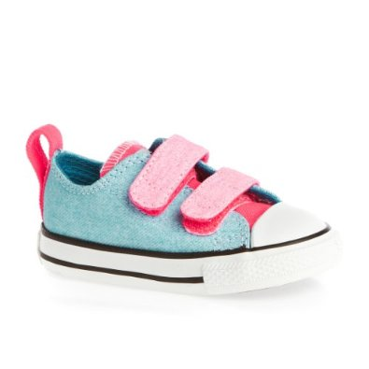Could we please also remind parents , to put velcro shoes on their children., We are outside everyday velcro shoes allow the children to be more independent Also may we remind you to put names on jumpers and coats .



Sonal Sportz

Coach Paul continues to visit and teach football skills in a fun enjoyable way..





**The recycling People from Belfast City Council are delighted to do a virtual reading on a recycling story about Mr. Rat.**

**Happy Birthday to those children who all celebrate their Birthday’s in April**

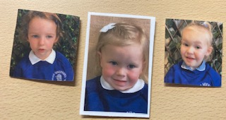

Please can we ask you to ring in morning to let us know your going to be late, so we can update dinners numbers. a.s.a.p



School Gate/Car Park

May I remind parents’ not to park in the school car park even if gate is open Please do not open our main gate.The safety of every child both in Primary and Nursery is Paramount

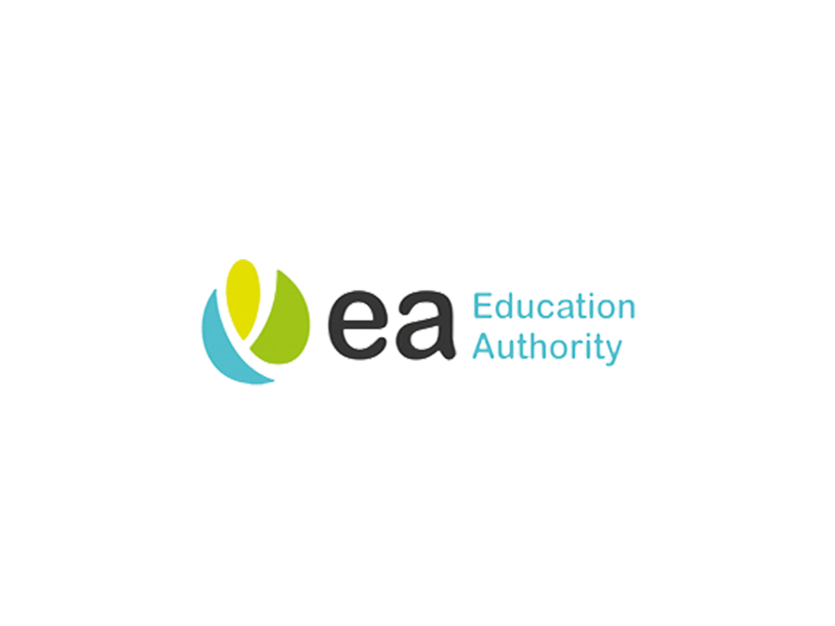**Admission for Primary School.**

**You will receive confirmation of your new Primary School for Sept 21, please inform your class teacher of your child’s placement.**

**We still have places available in GSNS in Sept 21, so if you know of anyone who has not yeh applied encourage them to phone the nursery ASAP**

